PRE-OWNED EQUIPMENT

DEALS NOT TO BE MISSED

1st October 2026

Revised equipment, immediately or shorlty available with a one-year warranty on the mechanical parts and 3 months on the electronic, electric and pneumatic components

PREMIA WS. Year 2022  Filling machine for single and connected bags  Machine previously used for filling water into BIB, in excellent condition, with a high-end configuration:  - Electromagnetic flow meter  - Laminar flow hood  - Type 2 gripper for VITOP high and short necks  - Crimped hoses  - 3-way valves for thorough circuit cleaning, air evacuation and nitrogen injection  - Analogue sensor for switching from a tap fitted on a long neck to a short neck  - Stainless steel filling head support  - Stainless steel electrical and pneumatic cabinet  - Machine supplied without pump (pump available as an optional extra)  - Exceptional opportunity – Please contact us for further information. | 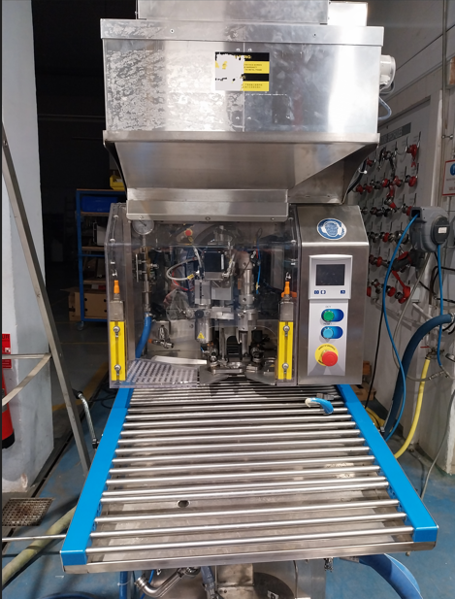
PREMIA WS Year 2025  Filling machine for individual and connected bags:  - Roller conveyor  - ALT40 pump  - Type 1 gripper for VITOP high neck bags  - Crimped hoses  - Machine with vacuum and inert gas injection | 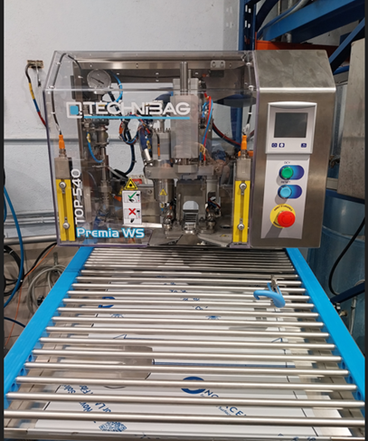
PREMIA. Year 2008  Filling machine for individual bags  - Roller conveyor  - ALT40 pump  - Type 1 gripper for VITOP high neck bags | 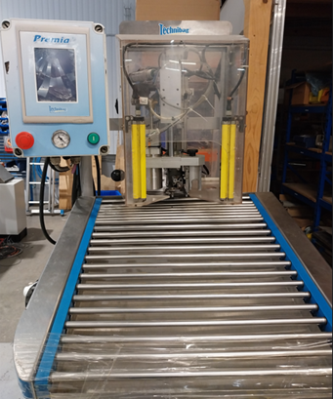
C-BOX GLUING MACHINE. Year 2022  Performance, precision and productivity  A modern machine equipped for optimised glue application:  - Independent control of upper and lower glue beads  - NORDSON PROBLUE glue applicator | 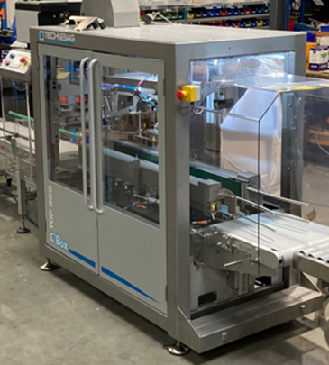
B BOOSTER 720 & C BOOSTER Year 2009  Automatic filling machine with or without automatic case loader  A refurbished unit:  - New electrical cabinet  - New pneumatic system  - New vacuum circuit  - New wine circuit | 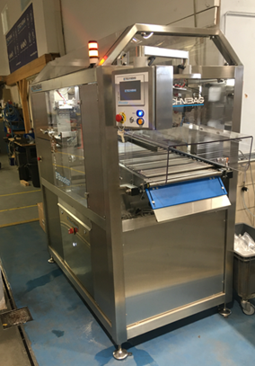
PALET’EASIER. Year 2022
Smart palletising assistance solution
Optimise your throughput and reduce operator strain:

- Accumulation conveyor for BIBs awaiting loading
- Time savings and improved ergonomics

POWERED BELT CONVEYOR – 2.92 m

ELINK JET inkjet printer
Batch number marking

- A simple and effective solution for industrial marking
- Ideal for production traceability

KIBER KSF-40 SCREW PUMP – Model 17
New pump

- Mounted on a trolley
- Integrated variable-frequency drive

